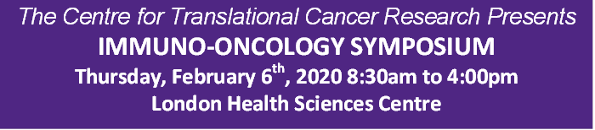

*The Centre for Translational Cancer Research Presents*

**IMMUNO-ONCOLOGY SYMPOSIUM**

**Thursday, February 6th, 2020 8:30am to 4:00pm**

**London Health Sciences Centre**

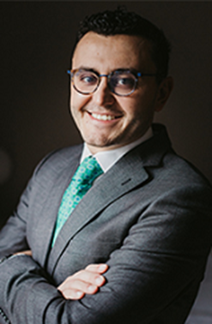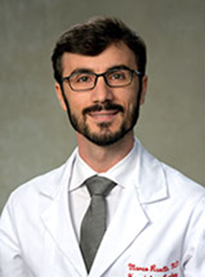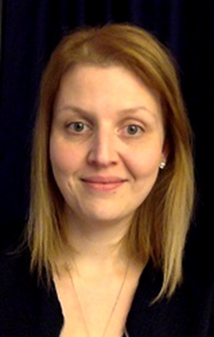

**With Guest Speakers**

**Dr. Bertrand Routy, MD. PhD.** Oncologist/Hematologist,Principal Scientist CHUM Research Centre,Assistant Professor Hematology/Oncology at University of Montreal. <https://www.chumontreal.qc.ca/crchum/chercheurs/bertrand-routy>

**Dr. Marco Ruella, MD.** Assistant Professor of Medicine, Division of Hematology/Oncology and the Center for Cellular Immunotherapies and Scientific Director of the Lymphoma Program, Perelman School of Medicine, University of Pennsylvania.<https://www.med.upenn.edu/cci/ruellalab/>

**Dr. Claire Vanpouille-Box, PhD.**Assistant Professor of Cell Biology in Radiation Oncology, Weill Cornell MedicalCollege <http://vivo.med.cornell.edu/display/cwid-clv2002>

Guest speakers also include **Drs. Ali Ashkar (McMaster), Laszlo Radvanyi (OICR), Brian Lichty (McMaster), Saman Maleki (UWO)** and **John Lenehan (UWO).**

Body: Arial 16

**To view agenda and register,** [**click here**](https://www.schulich.uwo.ca/ctcr/about_us/immunooncology_symposium.html)

**Contact Kimberly Scott 519-685-8600 x 75414 for more details**

